Name: Tran Khanh Tai
ID: ITITIU21300
Lab 5
Github link: https://github.com/KhanhTaiTran/Web-Application-Lab
EXERCISE 1: PROJECT SETUP & MODEL LAYER
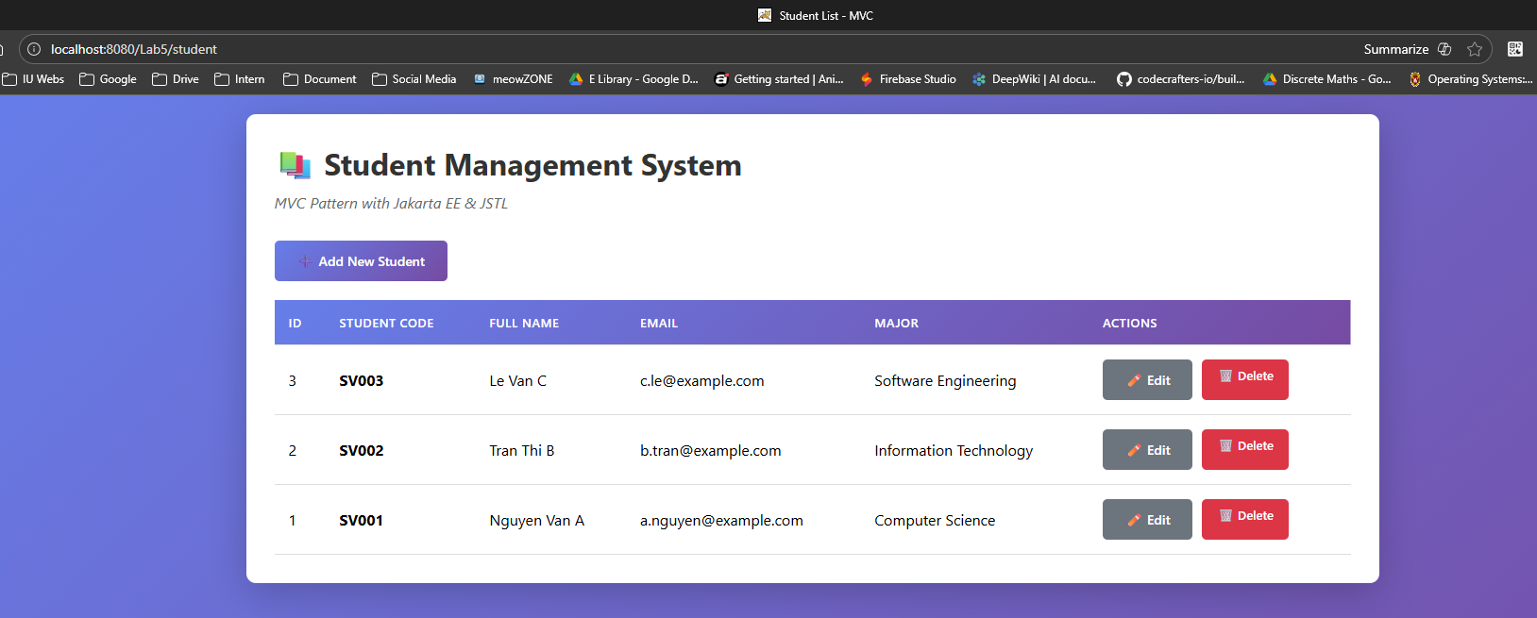
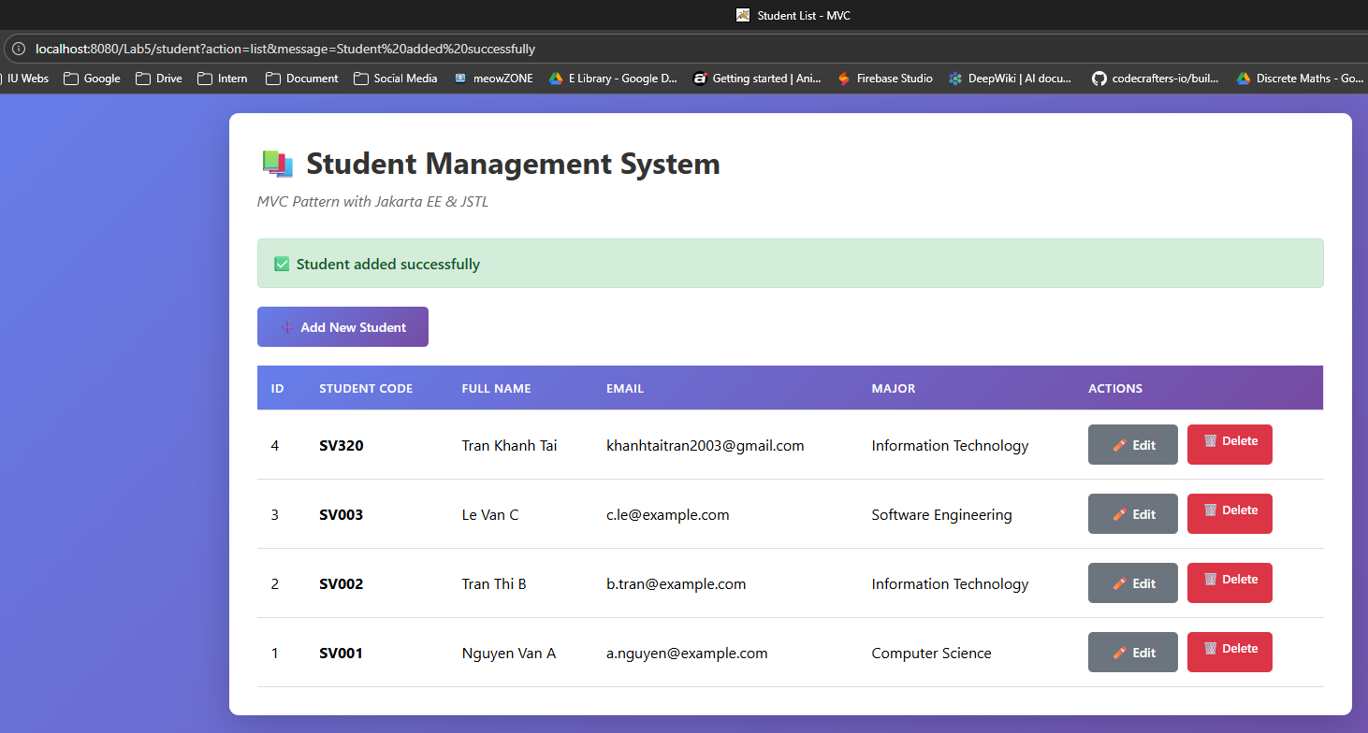
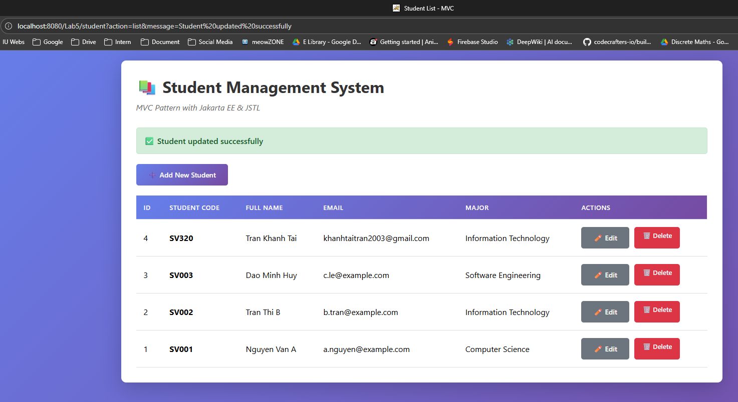
This lab use MVC pattern
1. Model (Student.java)
- Represents a student entity with properties: id, studentCode, fullName, email, major, createAt
- Simple POJO (Plain Old Java Object) with getters/setters
- Maps to database table structure
2. View (JSP Files)
- student-list.jsp - Displays all students in a table
- student-form.jsp - Form for adding/editing students
- Uses JSTL tags (<c:forEach>, <c:choose>) for dynamic content
- Contains inline CSS for styling with gradient purple theme
3. Controller (StudentController.java)
- Servlet that handles all HTTP requests (@WebServlet("/student"))
- Routes requests based on action parameter
- Delegates database operations to StudentDAO
4. DAO (StudentDAO.java)
- Data Access Object pattern
- Handles all database CRUD operations
- Uses JDBC to connect to MySQL database

Flow:
Listing student:
User visits → /student → doGet() → listStudents() → StudentDAO.getAllStudents() → MySQL query → Returns List<Student> → Forward to student-list.jsp → Display table
Adding student:
Click "Add New" → /student?action=new → showNewForm()
→ Forward to student-form.jsp (empty form)
→ User fills form → Submit → doPost() with action=insert
→ insertStudent() → StudentDAO.addStudent() → INSERT SQL
→ Redirect to /student?message=success
Editing Student:
Click "Edit" → /student?action=edit&id=X → showEditForm()
→ StudentDAO.getStudentById(X) → SELECT SQL
→ Forward to student-form.jsp (pre-filled)
→ User updates → Submit → doPost() with action=update
→ updateStudent() → StudentDAO.updateStudent() → UPDATE SQL
Deleting Student:
Click "Delete" → Confirm → /student?action=delete&id=X
→ deleteStudent() → StudentDAO.deleteStudent(X)
→ DELETE SQL → Redirect with message

